**BAN_630_Optimization for Analytics**

**Case Assignment_2**

**Group 7 Members:**

|  |  |
| --- | --- |
| **Name** | **Net_ID** |
| *Madhu sudhan Reddy Puppala* | *uf1937* |
| *Mihir Mane* | *du3425* |

Answer 1:

IP mathematical model.

**Input Variables:**

Given NPV for various project indexes.

N1=60, N2=180, N3=80, N4=310, N5= 220, N6= 180, N7=410, N8=280, N9=380, N10=100, N11=260, N12=340

**Decision variables**:

From the given data decision variables will be the project that we are going to undertake for each project index.

There are 12 decision variables:

***D1, D2, D3, D4, D5, D6, D7, D8, D9, D10, D11, D12*** for project index 1, 2, 3, 4, 5, 6, 7, 8, 9, 10, 11, 12 respectively.

These decision variables are binary. (0 or 1)

**Objective function:**

Maximize total NPV

***TOTAL_NPV*** *= N1D1 + N2D2 + N3D3 + N4D4 + N5D5 + N6D6 + N7d7 + N8D8 + N9D9 + N10D10 + N11D11 + N12D12*

***TOTAL_NPV =*** *60D1 + 180D2 + 80D3 + 310D4 + 220D5 + 180D6 + 410D7 + 280D8 + 380D9 + 100D10 + 260D11 + 340D12*

**Constraints:**

Capital expenditure for company is Y1, Y2, Y3 for year 1, 2, 3 respectively.

Constraint 1:

*Y1+Y2+Y3 <= 10,000,000,000*

Constraint 2:

For Year 1: *Y1 <= 4,000,000,000*

For Year 2: *Y2 <= 4,000,000,000*

For Year 3: *Y3 <= 4,000,000,000*

Constraint 3:

Let projects approved for FA1, FA2, FA3 be x1, x2, x3 respectively.

*x1 >= 1, x2 >= 1, x3 >= 1*

Answer 2:

After running the solver on excel the projects that are approved are 2, 3, 4, 5, 6, 7, 8, 9, 11.

So, the decision variables D2, D3, D4, D5, D6, D7, D8, D9, D11 will be 1 (project undertaken).

We got 4 projects undertaken in FA1, 4 in FA2 and 1 project in FA3 and maximized the total NPV to $2.3 billion.

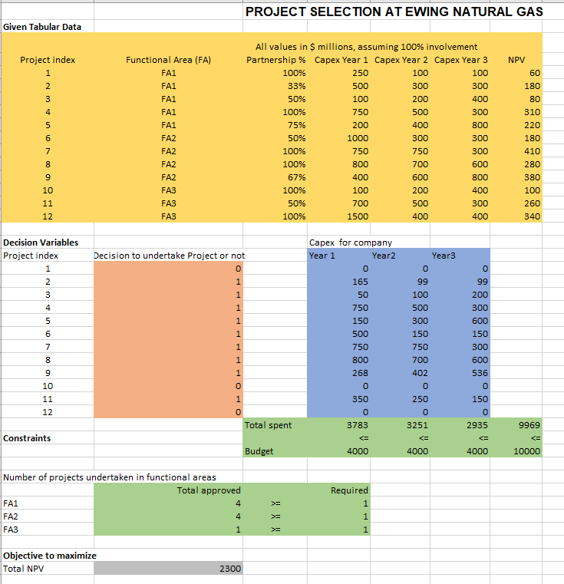

Answer 3:

Cliff is wrong because ultimately the value of NPV is dependent on the budget, as the amount of budget given is a constraint so if the budget increases the total capital expenditure per year that is Y1, Y2, Y3 will also increase.

If we increase the total budget from $10 billion to $11 billion the value of NPV increases from $2.3 billion to $2.4 billion. If we increase the value of total budget further, we do not get a NPV increase as it stays constant even if it is increased to $15 billion.

If we increase the year 1, year 2, year 3 budget individually from $4 billion to $7 billion the value of NPV does not change, it remains $2.3 billion.

Answer 4:

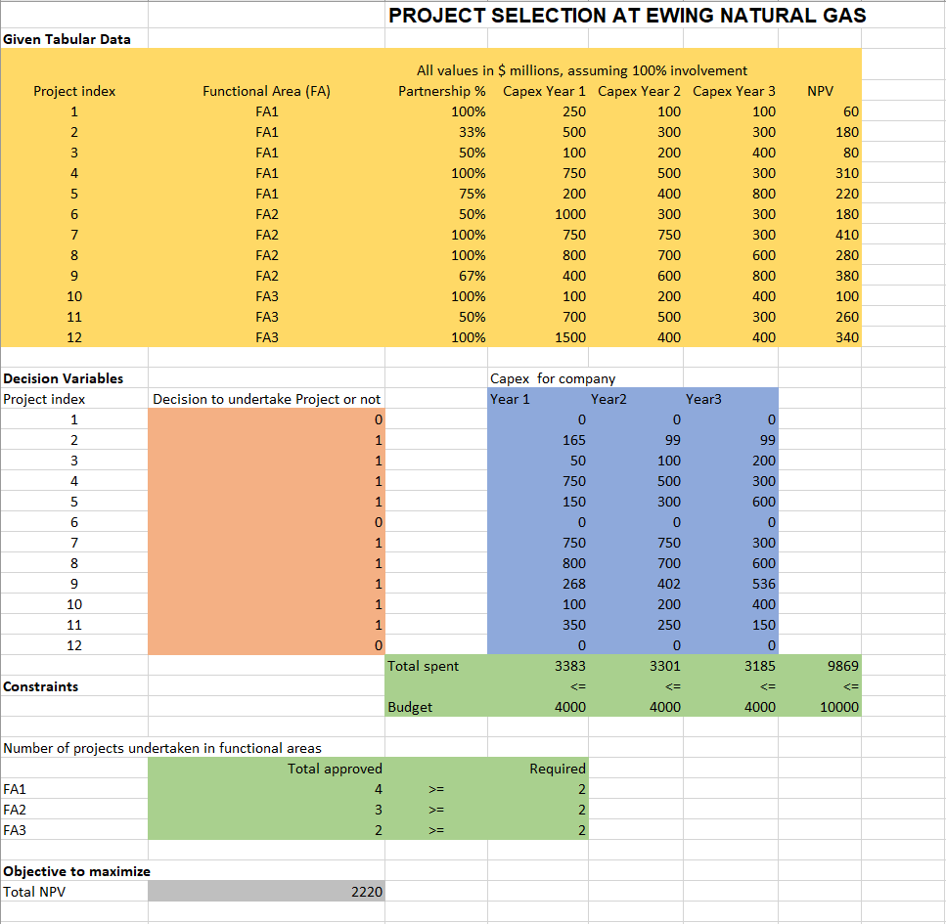

If we give minimum of 2 project per functional area then the total NPV value decreases from $2.3 billion to $2.22 billion.

The value of the constraint changes to:

*x1 >= 2, x2 >= 2, x3 >= 2*

Answer 5:

If Cliff decides to limit the number of joint partnerships from 3 to 6. In this case if the maximum number of joint partners can be 3 then total NPV decreases to $2.02 billion. If we increase this number to 4 we get the total NPV to be $2.2 billion. For 5 number of joint partnerships the value of NPV changes to $2.22 billion. Lastly, if we increase the number to 6 we get a total NPV of $2.3 billion, which is the maximum out of all the possible outcomes of NPV. So, the best number of allowable joint partnerships should be 6 as it is giving the maximum NPV.

